|  |
| --- |
| National University of Sciences and Technology |
| Communication Systems |
| Project Report |
|  |
| **Group 12 BEE 11-B** |
| **1/5/2022** |

# TEAM MEMBERS

## NAME Registration No

### Ch. Muhammad Shaheer Yasir 286021

### Muhammad Hamza 290951

### Muhammad Shayan Khan Manj 310591

### Abdullah Jamil 295474

# Objectives

The primary objectives of our project are to: -

* Generate a Message and a Carrier Signal and then implement frequency modulation.
* Demodulate the FM signal using frequency discriminator method.
* Perform the simulation of the project on software and implement it on hardware.

# Introduction

In order to send analog signal (e.g., sound, video, image) over long distances, first the signal have to be modulated. Modulation is the process of varying one or more properties of a high frequency signal also called carrier according to message or modulating signal. Modulation has different types:

1. Amplitude Modulation
2. Angle Modulation
3. Pulse Modulation
4. Spread Spectrum

The angle modulation is further divided in two types:

* Frequency Modulation
* Phase Modulation

# Working Principles

In our project, our main focus was to transmit and demodulate frequency modulated signal. So, let’s define frequency modulation.

Frequency modulation is the process of varying the frequency of the carrier signal linearly with the message signal. The frequency of the modulated wave remains constant as the carrier wave frequency when the message signal is at zero. The frequency increases when the message signal reaches its maximum amplitude. Likewise, with the decrease in amplitude of the message signal, the frequency also decreases. The following diagrams shows the phenomenon explained above:

Frequency modulation can be generated either by direct method or indirect method.

We are using the direct method and further implementing varactor diode modulator to achieve frequency modulation.

We have used the Hartley oscillator in our project to generate the carrier signal whose frequency is:

Where

C is a constant and k is the constant of sensitivity of varactor diode.

For the demodulation part, FM can be demodulated using frequency discrimination and phase discrimination methods. For our project, frequency discrimination method is required. Demodulation through frequency discrimination method can be implemented through simple slope detector and balanced slope detector. We have implemented simple slope detector to demodulate our message signal. The theoretical circuit of a simple slope detector is shown as follows:

After passing through Envelope detector, we will recover our message signal on the receiver side.

# Design and Components Used

First, we have designed a circuit to generate the carrier signal.

We used a combination of resistors, capacitors, variable resistor and a transistor BC548BP to generate a carrier signal using RC phase shift oscillator. Here, that variable resistor is used to change the frequency of the carrier signal.

After generation of the carrier signal, we have implemented our modulation circuit as follows:

Here, we have a used a combination of resistors, capacitors, inductor, a variable capacitor and a transistor BC1078P to generate a frequency modulated signal. The variable capacitor can be used to change the modulation level.

To demodulate the above message signal, we have used a simple slope detector whose schematic is as follows:

Here we have used a transformer of 1:1 coupling factor and 10mH on both primary and secondary side. It is used here to pass the high frequency signals. The LM339 chip is a voltage differential comparator which is used here as an envelope detector. Different resistors and capacitors are used to design the logic to extract the message signal.

# Hardware Circuit

The modulation circuit on hardware is as follows

The demodulation circuit on hardware is as follows

# Results from Simulations

The message signal in our simulation is as follows:

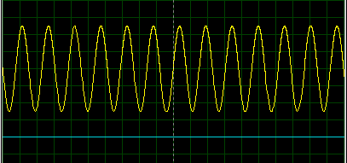

The carrier signal in our simulation is as follows:

The modulated signal in our simulation is as follows:

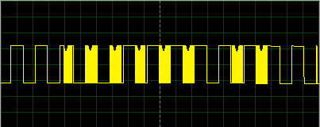

The signal after passing through the differentiator in simulation is as follows:

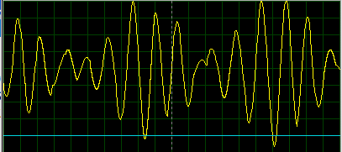

The signal after passing through envelope detector is as follows:

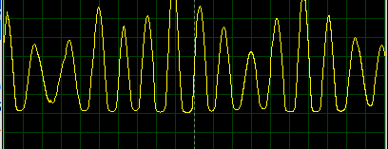

# Results from Hardware Output

The modulated signal is as follows:

The demodulated signal from the hardware output is as follows:

# Limitations

* The output is not as linear as compared to balanced slope detector and Armstrong detector.
* The signal cannot be received at its maximum signal strength because it requires the signal to be centered on the falling response of the filter.
* Much higher level of noise and interference is experienced.

# Applications

Frequency modulation is widely used in:

* FM radio broadcasting
* Telemetry
* Radar
* Seismic prospecting and monitoring newborns for seizures via EEG
* Two-way radio systems
* Sound synthesis
* Magnetic tape-recording systems

And some video-transmission systems.

# Conclusions

In this project, we frequency modulated a message signal and then demodulated it using simple slope detector. The simple slope detector is a differentiator along with an envelope detector. Its output is highly non-linear, and it has distortion in it due to which it’s not much preferrable nowadays as compared to balanced slope detector and phase-locked loop. Although all the components of this project were lost cost and easily accessible, however the transformer required wasn’t available in the market. So, we designed our own transformer of the required ratings.

# References

<https://www.elprocus.com/frequency-modulation-and-its-applications/>

<https://www.tutorialspoint.com/analog_communication/analog_communication_angle_modulation.htm>

<http://www.winlab.rutgers.edu/~crose/322_html/envelope_detector.html>

<https://www.sciencedirect.com/topics/computer-science/envelope-detector>

<https://www.electronics-notes.com/articles/radio/modulation/fm-frequency-demodulation-slope-detector-discriminator.php>